**Tugas Pertemuan Ke – 3**

**Bab 3 : View & View Group**

|  |  |
| --- | --- |
| **Nama** | Shohibul Maarif |
| **Nim** | 2018066 |
| **Kelas** | C |
| **Pemberi Tugas** | Moch Arif Rochmanullah (2118100) |

1. **Nama projek yang ditugaskan (Membuat Tampilan View Group).**
2. **Langkah – langkah pengerjaan**
3. Buka Android Studio kemudian buat *project* baru pilih *empty* *project*.

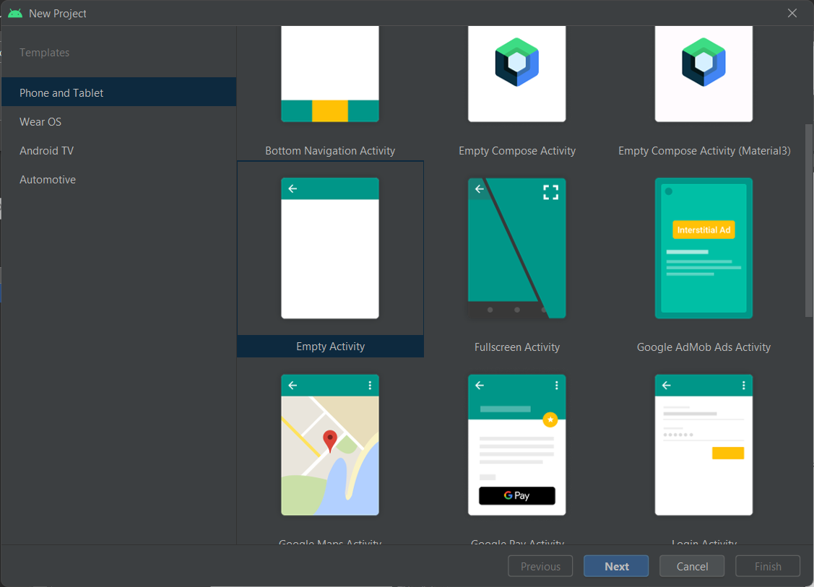

#### Membuat *project* baru

1. Kemudian membuat *icon* dengan cara pergi ke *folder* *res* selanjutnya *drawable* kemudian *new* selanjutnya *Vector* *Asset*.

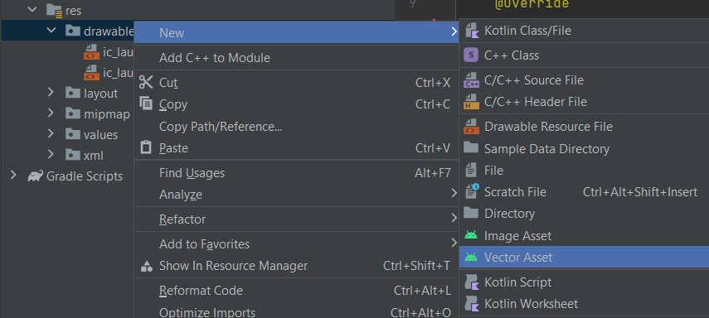

#### *Vector Asset*

1. klik ikon pada “*Clip* *Art*” lalu pilih ikon yang sudah disediakan oleh android studio, cari 4 ikon yaitu *star* *half*, *star* *rate*, *arrow* *back*, dan *favorite* *border*.

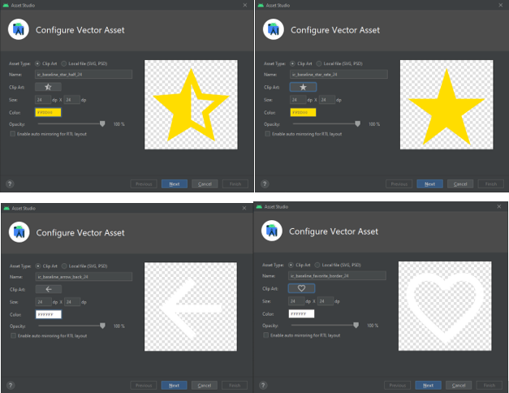

#### Menambahkan *icon*

1. Selanjutnya siapkan gambar untuk bahan, kemudian *drag* *and* *drop* ke dalam *folder* *res* *drawable*.

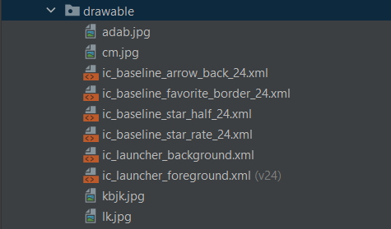

#### Menambahkan *file* gambar

1. Selanjutnya pilih *res* kemudian *layout* kemudian activity_main.xml. Lalu ubah *code* dalam activity_main.xml menjadi seperti dibawah.

|  |
| --- |
| <?xml version="1.0" encoding="utf-8"?>  <ScrollView  xmlns:android="http://schemas.android.com/apk/res/android"  xmlns:app="http://schemas.android.com/apk/res-auto"  xmlns:tools="http://schemas.android.com/tools"  android:layout_width="match_parent"  android:layout_height="match_parent"  tools:context=".MainActivity">  <LinearLayout  android:layout_width="match_parent"  android:layout_height="wrap_content"  android:orientation="vertical"  android:background="@color/grey_dark">  </LinearLayout>  </ScrollView> |

*Source* *code* diatas berada pada file activity_main.xml, *source* *code* tersebut digunakan untuk mengatur *layout* *width* dan *layout* *height*, *source* *code* tersebut memiliki orientasi vertikal.

1. Selanjutnya membuat desain menggunakan *card* *view*, *relative* *layout* dan image *view*. Didalam linear *layout* ketikan *code* berikut.

|  |
| --- |
| <androidx.cardview.widget.CardView  android:layout_width="match_parent"  android:layout_height="wrap_content"  app:cardCornerRadius="15dp"  app:cardUseCompatPadding="true"> <RelativeLayout  android:layout_width="match_parent"  android:layout_height="wrap_content">  <ImageView android:layout_width="match_parent"  android:layout_height="300dp"  app:srcCompat="@drawable/lk"  android:scaleType="fitXY"/>  <ImageView android:layout_width="wrap_content"  android:layout_height="wrap_content"  android:layout_margin="10dp"  android:layout_marginTop="10dp"  android:layout_alignParentStart="true"  app:srcCompat="@drawable/ic_baseline_arrow_back_24"/>  <ImageView  android:layout_width="wrap_content"  android:layout_height="wrap_content"  app:srcCompat="@drawable/ic_baseline_favorite_border_24"  android:layout_gravity="end" android:layout_marginEnd="10dp"  android:layout_marginTop="10dp"  android:layout_alignParentEnd="true"/>  </RelativeLayout>  </androidx.cardview.widget.CardView> |

*Source* *code* diatas digunakan untuk membuat tampilan bagian atas dari aplikasi. *Source* *code* tersebut memiliki *layout* *width* dan *layout* *height* yang sudah diatur, kemudian memiliki tag *relative* *layout*, untuk gambar *source* *code* diatas menggunakan fungsi *srcCompat* kemudian dilanjutkan nama folder kemudian nama file gambar.

1. Jika sudah maka tampilan akan seperti dibawah:

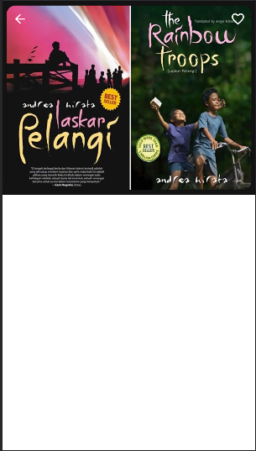

#### Hasil Tampilan

1. Selanjutnya membuat desain deskripsi menggunakan *card* *view*, *linear* *layout*, *text* *view*, *image*, dan *button*. Ketikan *code* berikut dibawah *card* *view* gambar *lk*.

|  |
| --- |
| <androidx.cardview.widget.CardView  android:layout_width="match_parent"  android:layout_height="match_parent"  app:cardCornerRadius="10dp"  app:cardUseCompatPadding="true"  app:cardBackgroundColor="@color/grey_card">  <LinearLayout  android:layout_width="match_parent"  android:layout_height="wrap_content"  android:orientation="vertical"  android:layout_marginStart="10dp">  <TextView  android:id="@+id/textView"  android:layout_width="wrap_content"  android:layout_height="wrap_content"  android:textSize="24sp"  android:paddingStart="10dp"  android:text="Laskar Pelangi"  android:textColor="@color/white"  android:layout_marginBottom="10dp"/>  <LinearLayout  android:layout_width="match_parent"  android:layout_height="wrap_content"  android:orientation="horizontal">  <ImageView  android:layout_width="wrap_content"  android:layout_height="wrap_content"  app:srcCompat="@drawable/ic_baseline_star_rate_24"/>  <ImageView  android:layout_width="wrap_content"  android:layout_height="wrap_content"  app:srcCompat="@drawable/ic_baseline_star_rate_24"/>  <ImageView  android:layout_width="wrap_content"  android:layout_height="wrap_content"  app:srcCompat="@drawable/ic_baseline_star_rate_24"/>  <ImageView  android:layout_width="wrap_content"  android:layout_height="wrap_content"  app:srcCompat="@drawable/ic_baseline_star_rate_24"/>  <ImageView  android:layout_width="wrap_content"  android:layout_height="wrap_content"  app:srcCompat="@drawable/ic_baseline_star_half_24"/>  <TextView  android:id="@+id/textView2"  android:layout_width="wrap_content"  android:layout_height="wrap_content"  android:layout_weight="1"  android:text="4.8"  android:textColor="@color/white"  android:layout_marginTop="3dp"  android:layout_marginStart="2dp"/>  </LinearLayout>  <TextView  android:id="@+id/textView3"  android:layout_width="match_parent"  android:layout_height="wrap_content"  android:text="@string/deskription"  android:textColor="@color/white"  android:layout_marginBottom="15dp"  android:layout_marginStart="10dp"  android:layout_marginEnd="15dp"  android:layout_marginTop="15dp"/>  <TextView  android:id="@+id/textView4"  android:layout_width="match_parent"  android:layout_height="wrap_content"  android:text="@string/ingredients"  android:textColor="@color/white"  android:layout_marginStart="10dp"/>  <TextView  android:id="@+id/textView5"  android:layout_width="match_parent"  android:layout_height="wrap_content"  android:text="@string/Genre"  android:textColor="@color/white_blur"  android:layout_marginStart="10dp" />  <LinearLayout  android:layout_width="match_parent"  android:layout_height="wrap_content"  android:orientation="horizontal"  android:layout_marginBottom="15dp">  <LinearLayout  android:layout_width="match_parent"  android:layout_height="wrap_content"  android:orientation="vertical"  android:layout_marginTop="15dp"  android:layout_weight="0.5">  <TextView  android:id="@+id/textView6"  android:layout_width="wrap_content"  android:layout_height="wrap_content"  android:layout_weight="1"  android:text="@string/price"  android:textColor="@color/white"  android:layout_marginStart="10dp" />  <TextView  android:id="@+id/textView7"  android:layout_width="wrap_content"  android:layout_height="wrap_content"  android:layout_weight="1"  android:text="@string/Harga_buku"  android:textColor="@color/white"  android:layout_marginStart="10dp"  android:textSize="24sp"/>  </LinearLayout>  <Button  android:id="@+id/button"  android:layout_width="300dp"  android:layout_height="wrap_content"  android:layout_weight="0.5"  android:text="Order Now"  android:textAllCaps="false"  android:layout_marginEnd="15dp"  android:layout_gravity="center_vertical"/>  </LinearLayout>  </LinearLayout>  </androidx.cardview.widget.CardView> |

*Source* *code* diatas digunakan untuk membuat tampilan dibawah *cardview* sebelumnya. *Source* *code* diatas menampilkan *text*, rating, dan juga tombol. *Source* *code* diatas memiliki *tag* *linear* *layout*, *tag* *text* *view*, dan *tag image view*.

1. Jika berhasil maka tampilan akan seperti gambar dibawah.

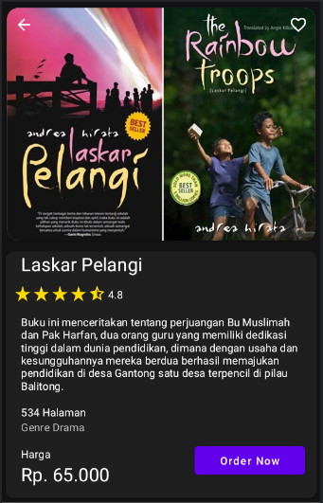

#### Hasil Tampilan

1. Selanjutnya membuat tampilan menu menggunakan *card* *view* dan *table* *layout*. Ketikan *code* berikut dibawah *card* *view* deskripsi.

|  |
| --- |
| <androidx.cardview.widget.CardView  android:layout_width="match_parent"  android:layout_height="match_parent"  app:cardCornerRadius="10dp"  app:cardBackgroundColor="@color/grey_card"  app:cardUseCompatPadding="true">  <LinearLayout  android:layout_width="match_parent"  android:layout_height="match_parent"  android:orientation="vertical">  <TextView  android:id="@+id/textView8"  android:layout_width="match_parent"  android:layout_height="wrap_content"  android:text="Saran Buku"  android:textColor="@color/white"  android:textSize="24sp"  android:layout_marginStart="15dp"  android:layout_marginTop="15dp"/>  <TableLayout  android:layout_width="match_parent"  android:layout_height="match_parent"  android:layout_marginStart="15dp"  android:layout_marginEnd="15dp"  android:layout_marginBottom="15dp">  <TableRow  android:layout_width="match_parent"  android:layout_height="match_parent" >  <LinearLayout  android:layout_width="match_parent"  android:layout_height="match_parent"  android:orientation="horizontal">  <androidx.cardview.widget.CardView  android:layout_width="wrap_content"  android:layout_height="wrap_content"  app:cardCornerRadius="5dp"  app:cardUseCompatPadding="true">  <ImageView  android:id="@+id/imageView1"  android:layout_width="150dp"  android:layout_height="100dp"  app:srcCompat="@drawable/cm" />  </androidx.cardview.widget.CardView>  <LinearLayout  android:layout_width="match_parent"  android:layout_height="wrap_content"  android:orientation="vertical"  android:layout_gravity="center_vertical">  <TextView  android:layout_width="match_parent"  android:layout_height="wrap_content"  android:text="5 cm"  android:textSize="20dp"  android:textColor="@color/white"/>  <LinearLayout  android:layout_width="match_parent"  android:layout_height="match_parent"  android:orientation="horizontal">  <ImageView  android:layout_width="30dp"  android:layout_height="wrap_content"  app:srcCompat="@drawable/ic_baseline_star_rate_24"  android:foregroundGravity="left"/>  <TextView  android:layout_width="wrap_content"  android:layout_height="wrap_content"  android:text="4.8"  android:textColor="@color/white"  android:layout_gravity="center_vertical"/>  </LinearLayout>  <TextView  android:layout_width="match_parent"  android:layout_height="wrap_content"  android:text="Rp. 100.000"  android:textSize="20dp"  android:textColor="@color/white"/>  </LinearLayout>  </LinearLayout>  </TableRow>  <TableRow  android:layout_width="match_parent"  android:layout_height="match_parent" >  <LinearLayout  android:layout_width="match_parent"  android:layout_height="match_parent"  android:orientation="horizontal">  <androidx.cardview.widget.CardView  android:layout_width="wrap_content"  android:layout_height="wrap_content"  app:cardCornerRadius="5dp"  app:cardUseCompatPadding="true">  <ImageView  android:id="@+id/imageView2"  android:layout_width="150dp"  android:layout_height="100dp"  app:srcCompat="@drawable/kbjk" />  </androidx.cardview.widget.CardView>  <LinearLayout  android:layout_width="match_parent"  android:layout_height="wrap_content"  android:orientation="vertical"  android:layout_gravity="center_vertical">  <TextView  android:layout_width="match_parent"  android:layout_height="wrap_content"  android:text="Kami (Bukan) Sarjana kertas"  android:textSize="20dp"  android:textColor="@color/white"/>  <LinearLayout  android:layout_width="match_parent"  android:layout_height="match_parent"  android:orientation="horizontal"><ImageView  android:layout_width="30dp"  android:layout_height="wrap_content"  app:srcCompat="@drawable/ic_baseline_star_rate_24"  android:foregroundGravity="left"/>  <TextView  android:layout_width="wrap_content"  android:layout_height="wrap_content"  android:text="4.8"  android:textColor="@color/white"  android:layout_gravity="center_vertical"/>  </LinearLayout>  <TextView  android:layout_width="match_parent"  android:layout_height="wrap_content"  android:text="Rp. 40.000"  android:textSize="20dp"  android:textColor="@color/white"/>  </LinearLayout>  </LinearLayout>  </TableRow>  <TableRow  android:layout_width="match_parent"  android:layout_height="match_parent" >  <LinearLayout  android:layout_width="match_parent"  android:layout_height="match_parent"  android:orientation="horizontal">  <androidx.cardview.widget.CardView  android:layout_width="wrap_content"  android:layout_height="wrap_content"  app:cardCornerRadius="5dp"  app:cardUseCompatPadding="true">  <ImageView  android:id="@+id/imageView"  android:layout_width="150dp"  android:layout_height="100dp"  app:srcCompat="@drawable/adab" />  </androidx.cardview.widget.CardView>  <LinearLayout  android:layout_width="match_parent"  android:layout_height="wrap_content"  android:orientation="vertical"  android:layout_gravity="center_vertical">  <TextView  android:layout_width="match_parent"  android:layout_height="wrap_content"  android:text="Adab Diatas Ilmu"  android:textSize="20dp"  android:textColor="@color/white"/>  <LinearLayout  android:layout_width="match_parent"  android:layout_height="match_parent"  android:orientation="horizontal">  <ImageView  android:layout_width="30dp"  android:layout_height="wrap_content"  app:srcCompat="@drawable/ic_baseline_star_rate_24"  android:foregroundGravity="left"/>  <TextView  android:layout_width="wrap_content"  android:layout_height="wrap_content"  android:text="4.8"  android:textColor="@color/white"  android:layout_gravity="center_vertical"/>  </LinearLayout>  <TextView  android:layout_width="match_parent"  android:layout_height="wrap_content"  android:text="Rp. 120.000"  android:textSize="20dp"  android:textColor="@color/white"/>  </LinearLayout>  </LinearLayout>  </TableRow>  <TableRow  android:layout_width="match_parent"  android:layout_height="match_parent" />  </TableLayout>  </LinearLayout>  </androidx.cardview.widget.CardView> |

*Source* *code* diatas digunakan untuk membuat tampilan pilihan menu *service* yang ada pada aplikasi. Pada program tersebut bisa discroll ke bawah pada tampilan menu. *Source* *code* tersebut memiliki tag *Linear* *Layout*, *tag* *tex* *view*, *tag* *Table* *Layout*, *tag* *Table* *Row*, dan *tag* *image* *view*.

1. Jika berhasil maka akan tampil seperti gambar dibawah.

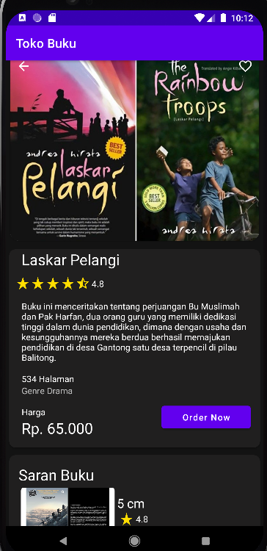

#### Hasil *Running*

1. **Link repository github**

https://github.com/AryaRizky/Tugas3_2018017